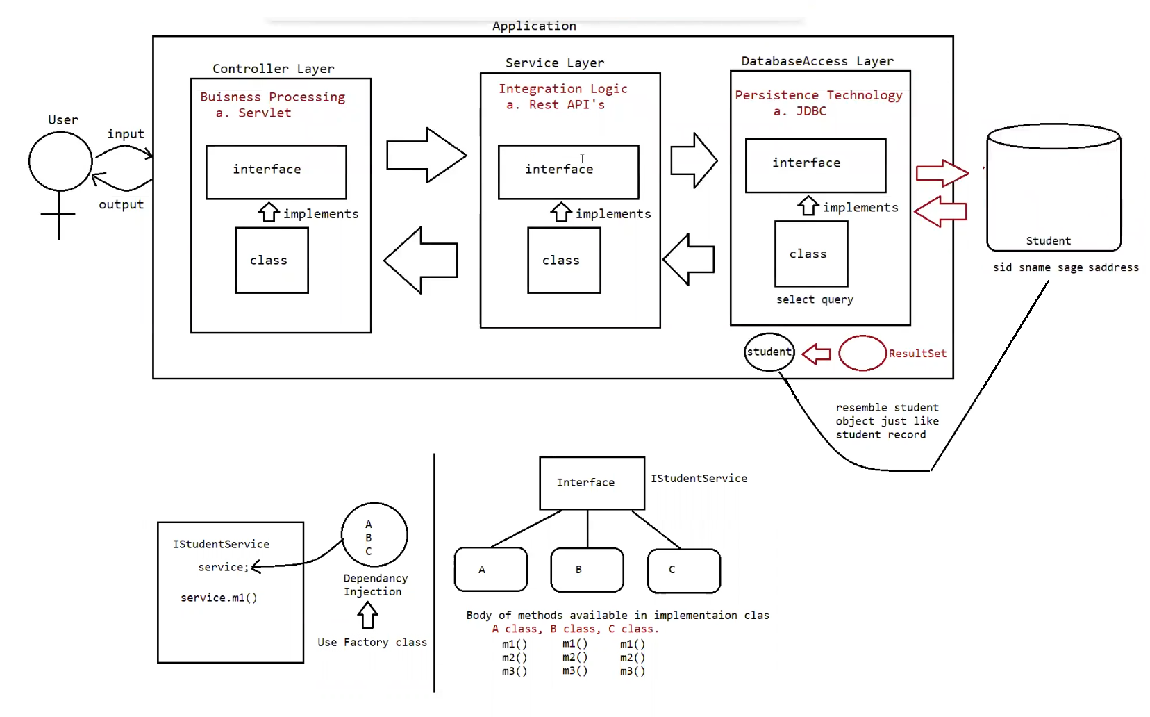

Need of DTO in projects

DTO -> It stands for Data Transfer Object.

This object is used for transferring the data from one layer to another layer in realtime applications.

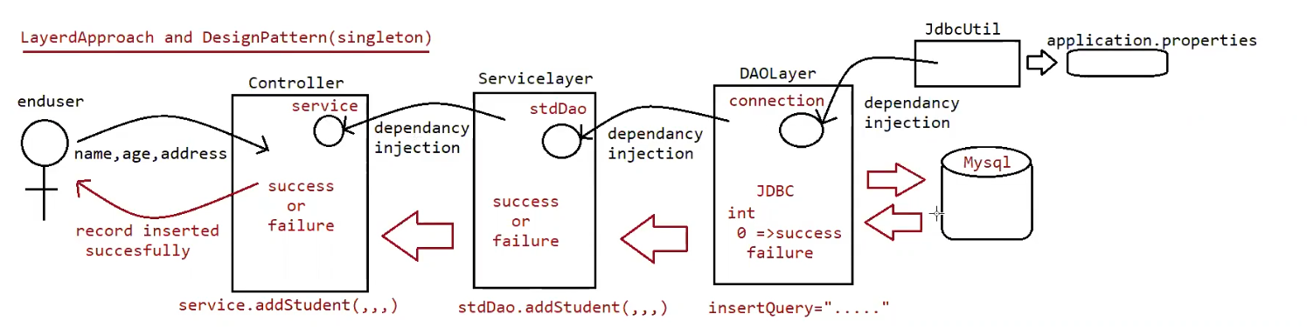

SQL> create table student(sid int, sname nvarchar2(15) , sage int , saddress nvarchar2(15)

);

Table created.

SQL> insert into student values(1,'pavan',24,'vijayawada');

1 row created.

SQL> insert into student values(2,'anand',23,'vijayawada');

1 row created.

SQL> insert into student values(3,'charan',23,'ongole');

1 row created.

SQL> insert into student values(4,'pavankumar',24,'vijayawada');

1 row created.

SQL> insert into student values(5,'tarun',24,'vijayawada');

1 row created.

SQL> insert into student values(6,'mpavan',24,'vijayawada');

1 row created.

SQL> insert into student values(7,'ppavan',24,'vijayawada');

1 row created.

SQL> insert into student values(8,'teja',24,'vijayawada');

1 row created.

